**Project goals**

Our primary goal is to acquire deep learning methods and models in computer vision.

In the project, we will design, build and train a DNN model to classify and segment clouds organization patterns from satellite images.

Our secondary goal is achieving a competitive result by Kaggle website criterion.

**Challenge Overview**

Kaggle is an online community of data scientists and machine learners, owned by Google.

Among others, Kaggle offers machine learning competitions and data science challenges.  
  
Shallow clouds play a huge role in determining the Earth's climate. That is because they reflect a lot of sunlight back into space, thereby cooling our planet, while only contributing marginally to the greenhouse effect. This means that it’s really important to figure out how these clouds will change as our planet warms. Generally, they are also difficult to understand and to represent in climate models.

In this challenge, we will classify and segment different types of cloud organization. By that, researchers hope to improve their physical understanding of these clouds, which in turn will help them build better climate models and understand how clouds will shape our future climate.

**Data Analysis**

We are required to identify regions in satellite images that contain certain cloud formations, with label names: Fish, Flower, Gravel, Sugar.

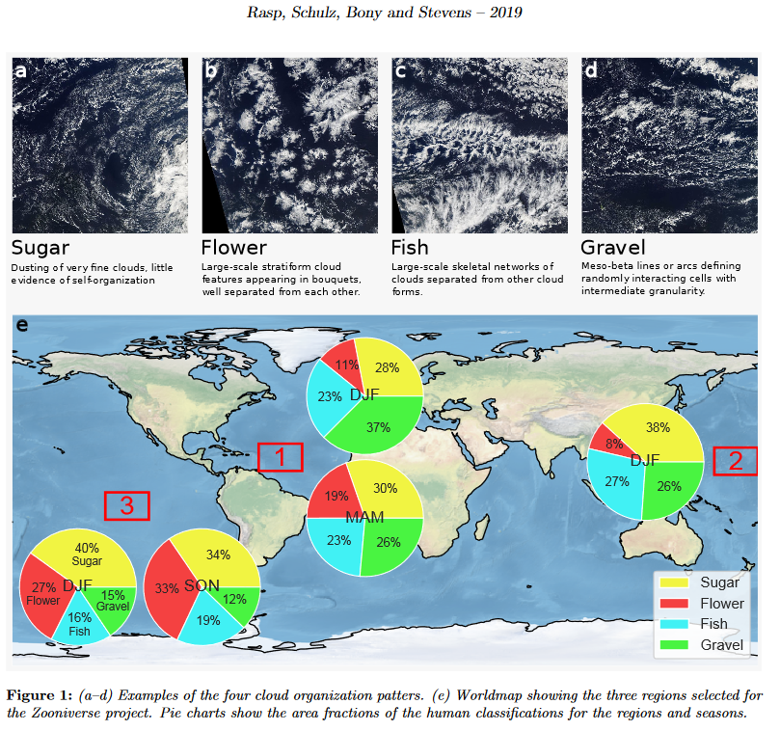

Figure [complete]: (*a*-*d*) Examples of the four cloud organization patterns. (*e*) World map showing pie charts of area fractions of the human classification for the regions and seasons. [complete]

(source: <https://www.kaggle.com/artgor/segmentation-in-pytorch-using-convenient-tools>)

Invariants:

* Each image has at least one cloud formation and can possibly contain up to all four
* There are 5546 images in the train set
* There are 3698 images in the test set
* Image size is 1400 X 2100 pixels
* The ground truth ship segmentation is encoded in RLE (Run Length Encoder).
* Cloud distribution in the data set:

2781 Fish clouds

2365 Flower clouds

2939 Gravel clouds

3751 Sugar clouds

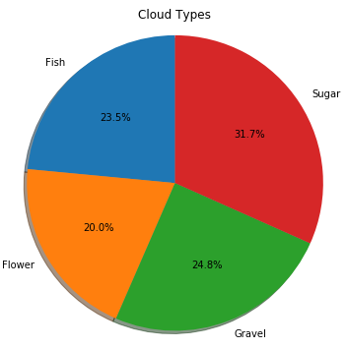

Figure (complete): Cloud types distribution in the dataset[complete]

(source: <https://www.kaggle.com/aleksandradeis/understanding-clouds-eda>)